WRIGHTINGTON HOSPITAL
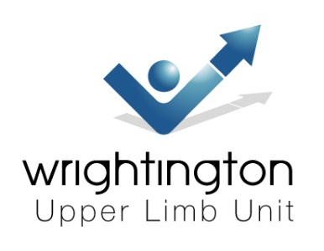
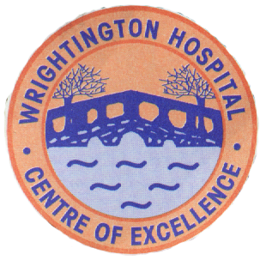
THE 3RD HAND DIPLOMA REVISION COURSE
26/27 JANUARY 2016
VENUE: CONFERENCE CENTRE
CONFERENCE HALL LANE, APPLEY BRIDGE, WIGAN WN6 9EP

Provisional Programme

Day 1, Tuesday 26 Jan 2016

Registration: 08.00 - 08.30

08.30 Welcome & Introduction
08.45 Practical neurophysiology
09.45 Radiology
10.15 COFFEE
10.30 Viva stations
12.00 LUNCH
13.00 Peripheral nerve injury
13.20 Tendon/Nerve Transfers
13.40 Hand surgery in tetraplegia, stroke
14.00 Microsurgery
14.30 Clinical cases stations
16.00 TEA
16.15 Flexor tendon surgery
16.40 Dupuytren contracture
17.00 Madelung, tumour, vascular
17.30 CLOSE (we will go straight over to the course dinner venue)

Day 2, Wednesday 27 Jan 2016

08.30 The child’s hand
09.15 OA/Inflammatory arthropathy
10.00 COFFEE
10.30 Viva stations
12.00 LUNCH
13.00 Distal radius
13.20 TFCC & DRUJ
13.40 The scaphoid
14.00 Wrist instability
14.30 Practical hand therapy
15.30 TEA
16.00 Infections
16.20 Lupus & scleroderma
16.40 Upper limb prosthesis
17.00 END

