Instructions To Playing Fields Car park

Head to the end of Northampton Street, and at the mini roundabout, take the first exit in the Queen’s Road.
Approximately 500 yards ahead is a pedestrian crossing, just by the large Eagle Gates.
The turning for the car park is a small gap in the fencing on the right hand side, just before the pedestrian crossing.
Please park considerately and remove your vehicle before 1900hrs as the car park gets locked each evening.
To enter the College, cross the pedestrian crossing and proceed through the small open gate in the bigger gates. Follow the sandy path to the end, going over Kitchen Bridge and turn left. This takes you into Third Court. Second Court, First Court, Chapel Court and North Court are then to the right. New Court and Cripps are to your left.
Nearest satnav postcode is between CB3 9AQ and CB3 9AH (which takes you to the Queen’s Road, very near to where the car park is located)
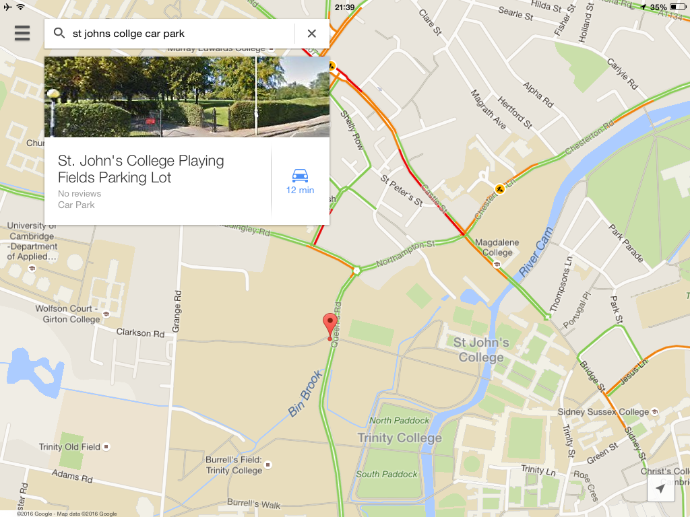
e).

