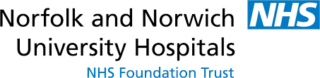
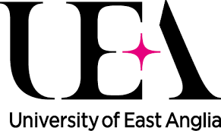
Orthopaedic Anatomy Course
Anatomy department, Queen’s Building, Norwich, UEA
Friday 23rd June 2017

A one day course reviewing the orthopaedic surgical approaches on cadavers. The course is limited to ST3 trainees on the East of England Orthopaedic Rotation. The course is fully funded by the Deanery.

0845 Meet outside the Anatomy department, Queen’s Building, UEA campus
0900 Session 1: Shoulder and elbow
Deltopectoral approach to the shoulder
Anterolateral approach to the humerus
Posterior approach to the humerus and elbow
1030 Coffee
1100 Session 2: Wrist and hand / Upper limb fasciotomies
Approaches to the elbow
“Henrys” anterior approach to the radius
Approaches to the wrist
1230 Lunch
1330 Session 3: Hip and knee
Posterior approach to the hip
Anterior approach to the hip
Posterior approach to the knee
Lateral approach to the distal femur/proximal tibia
1500 Tea
1530 Session 4: Foot & Ankle / Lower limb fasciotomies
Anterior approach to the ankle
Posterolateral approach to the ankle
Medial approach to the foot
Anterolateral and extended lateral approach to the foot

To reserve you place on this course please contact:
Mr David Loveday, Consultant Orthopaedic Surgeon, NNUH
David.loveday@nnuh.nhs.uk

