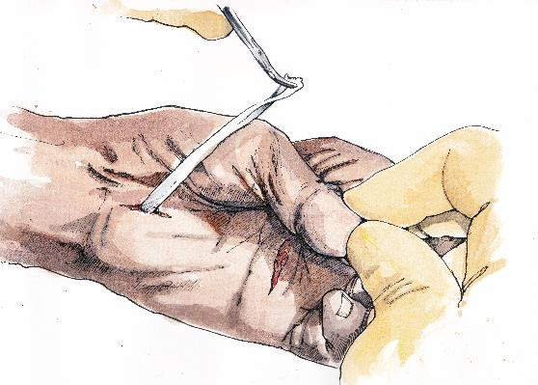

SO YOU WANT TO BE A HAND SURGEON…

One day course, organised by the British Society for Surgery of the Hand, on the practice of Hand Surgery. This course is aimed primarily at the Core Surgery Trainee who has decided on a career in Surgery, but has yet to choose specialty. It is, however, open to all, from Students to those in formal Plastic Surgery or Orthopaedic Training.

The course will cover all levels of a career in Hand Surgery, from the early stages of training up to practice as a Consultant. Faculty has been selected from all levels – Foundation doctor to Consultant Hand Surgeons.

Venue:
The Royal College of Surgeons of England, Lincoln’s Inn Fields, London, WC2A 3PE

Cost: Free; deposit retained against attendance

Date: Saturday 8th April 2017

Course Organiser and Faculty Head: Donald Sammut, Hand Surgeon

Details and Application: BSSH Secretariat: secretariat@bssh.ac.uk

SO YOU WANT TO BE A HAND SURGEON?
INTRODUCTION TO HAND SURGERY
Saturday 8th April 2017
Royal College of Surgeons of England, London

Registration Form

Name:
Medical School/Year:
Hospital/Grade:
Correspondence Address:
Mobile:
Email:

Please note: Attendance at the course is free of charge, however we request credit/debit card details from all delegates. If you do not attend, your booking will be subject to a £15 cancellation fee. This will be taken after the meeting.

Card Details:
Mastercard / Visa / Visa Electron / Maestro (Please circle)

Card Number:

Expiry Date: |  |  |  |  |  | Validation Code:

Billing Address:

I understand the above conditions of registration

Signature: | Date:

To book your place on the course, please complete this form and send to:

secretariat@bssh.ac.uk

British Society for Surgery of the Hand
Royal College of Surgeons,
35-43 Lincoln’s Inn Fields
London
WC2A 3PE

