EOE Orthopaedic Teaching & Education Association (EOETEA) /
Cambridge Trauma and Orthopaedic Club (CTOC)
AGENDA: Thursday 2nd August 2018
Venue: Armans House 1900-2145

Item no | Agenda Item |  | Presenter | Timing
- 1 | Introduction, apologies, conflict of interest |  | AM | 5
 | Minutes from the last meeting |  | AM | 5
 | Committee positions |  | AM | 10
 | CTOC Account handover |  | AM, JG | 5
 | Fundraising 2018-19 |  | AD | 5
 | Website, webmaster handover |  | MB | 10
 | Communications |  | RF | 5
 | List of members |  | AM, RF | 5
 | Teaching, curriculum, delivery of teaching  Teaching committee?? |  | NK, AM | 15
 | Merchandise, CTOC designs, EOE logo |  | MP | 10
 | Mentoring in T&O |  | LS | 5
 | BOTA update |  | RF | 5
 | ORCA update
 | STC update and training issues |  | MB, AM | 5
 | CTOC meeting 2019 |  | AM | 5
 | Club / Committee name  CTOC/EOATEA roles |  | AM | 10
 | Other business - transparency |  | AM | 5
Next meetings: After January teaching

TBC
1. AM welcome

2. Inaugral meeting so no previous minutes

3. Committee positions
DG shared this template structure which has come from SNSK & PHJ

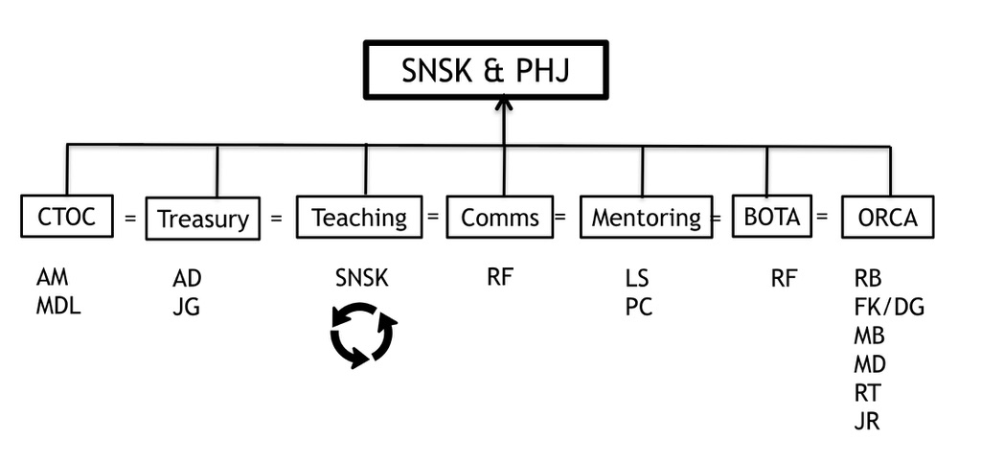

CTOC secretary: AM

Fundraising: AD role is to liaise with and raise money from industry. AD highlighted that his main sticking point at present is not knowing which companies have paid for the EOEORTHO contract that they signed up to so and so does not know which companies to chase for money.

Treasurer: JRG – Book keeping. NK and PHJ trying to get access to account. In process of have access from accounts transferred from GSK and JAHW. Barclays are being very slow. Plan for it to be possible for committee to be able to look at the account without have access to withdraw money.

Merchandise and marketing: MP – wants to work on sponsorship. Possibly organising fundraising events. Covers CTOC ties. What section of committee does this come under? Treasury

Teaching: NK happy to continue to oversee teaching. Paeds model / shoulder teaching good. All the hard work that has been put in is beginning to pay off. All agree that teaching is better when consultant led and consultants recruit colleagues / former trainees such as Finger-tip to shoulder and Shoulder FRCS teaching.

Webmaster/communication: MB and KF are the current webmasters. RF is going to take over from MB as MB has exam pending. MB has done an excellent job. RF aims to find an ST3 or ST4 to train and overlap with RF for 1 year which will mean she has completed 3 years in this post.

Mentoring & support fellow: LS working with PC to set up mentoring scheme. LS support fellow link for deanery for people returning from a break in training.

Bota: RF currently in role has succession plan for the next 3 years: Humza and Albert will do the next year and the year after that.

ORCA: RB and DG representing ORCA. Will present what they do and progress at CTOC meeting.

General points regarding the committee which were raised. The committee needs to be accountable, transparent and open and needs an AGM.

Timing of the AGM and role of the AGM led to some debate. AM concerned that if it were held on day of CTOC meeting it would further burden a busy schedule and therefore committee decided on a 30minute AGM to be held on the day of CTOC. The objectives of which would be:

Inform people what the committee was for and promote the committee.
Report committee’s activity
Raise interest in applying to be on committee

In order to save time during the AGM each committee member will produce a very short report (one paragraph) summarising role and output for the year which will be published on the EoEortho website in advance of the CTOC. Committee sit at the front and asked questions by the membership. Details of this not decided.

Attendance cannot agree if there should be a vote on the committee positions at the AGM or whether to advertise and application process. Committee agree on a skeletal AGM on the day of CTOC with advanced information published on the website. Further details to be decide at next meeting.

4. CTOC accounts
Access to accounts being transferred over to PHJ and NK.

5. Fundraising
See committee roles

6. Website, webmaster handover
See committee roles

7. Communications
See committee roles

8. List of members
NK Who are the members? JG / NK suggest the following scheme. Asking for £20 direct debit from all trainees coming to CTOC. This is a membership fee and acts a discount for CTOC. Maybe get £25 off cost of meal. Everyone post CCT is automatically a member.

9. Teaching
Teaching attendance. How to increase teaching attendances? Julie Graham has suggested that all teaching is registered through the Evelyn website. Suggested a retainer akin to cadaveric teaching. JG this might reduce last minute drop out but might not increase actual attendance.

10. Merchandise, CTOC designs, EOE logo
David Dandy does not this think this coat of arms represents the EAOC. AM / NK suggest professional designer. MP to come up with some basics designs / anyone else which could be formalised by a designer. All like the CTOC design which MP has come up with. AM and JG suggest a different font as the C looks a little like a G.

11. Mentoring
LS and PC trying to get mentoring scheme up and running. Survey sent to finishing ST3. Outcome: Low response rate. LS and PC have both been trained in mentoring and are going to be trained to train mentors. LS and PC will training SpRs who want to be mentors on the same day that ST3 induction is occurring. At the end of the day will pair mentors with ST3 mentees. LS and RF will liaise regarding advertising this opportunity.

12. BOTA update
RF to write deanery report for BOTA in November

13. ORCA update
ORCA hoping to publish results of MAJAX Project
DG very little response from trainees invited write book chapters

14. STC update and training issues: AM and MB
- There will be changes to CCT guidelines such as indicative numbers.
- Teaching attendance covered study budget / leave might be dependent on attending compulsory teaching.
- PHJ / deanery to consider 2-3 year mini rotations for ST3
- AD highlighted that there may not be enough spine jobs in the region to train the trainees.

15. CTOC meeting 2019:
Progress in organising day
Date organised: 29th March (day after STC meeting)
External speakers have been invited
Venue: Claire College both day and evening
JG and AM need to work out when will collect money
MP to enquire with trainees if there would be interest in making badge

16. Club / Committee name CTOC/EOATEA roles
AM CTOC seems to have stuck. MD the current president is happy with it. CTOC is a sensible change as it is a minimal change from COC. If put to a vote with options people will disagree. The committee feel a name change is inevitable given recent scandals and the support for the #metoo movement. The orthopods of the east of England and CTOC which considers itself an open non-sexist organisation would like to distance itself from anything which could be interpreted as being distasteful or in any way offensive.

NK EOEORTHO contract is an appropriate name for the contract that industry sign up to

17. Any other business
DG how can we make the meeting quicker next time?

18. Next meeting aim for January post a regional teaching day

