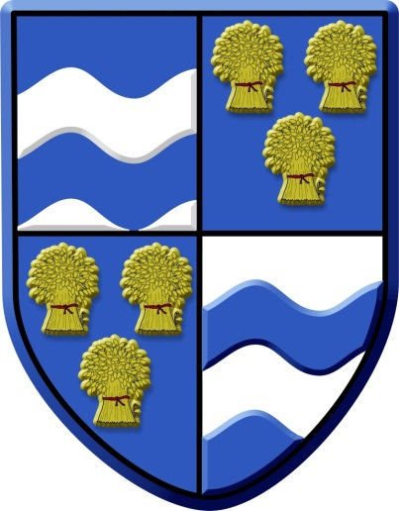
Provisional Program Friday 29th November 2019
8-45 -9-15: Registration
9-15 – 9-20: Welcome Mr Willem Schenk/ Mr James Jeffery
9-20 – 10-00: Registrar Presentations
10-00 – 10-30: Treating Osteoporotic Fractures Mr Peter Bates
10-30 – 11-00: Coffee Break
11-00 – 11-30: Registrar Presentations
11-30 – 12-00: Teaching and Learning Surgery Mr Mark Loeffler
12-00 – 12-30: Current management of Polytrauma Mr Peter Bates
12-30 – 12-45: Award for best registrar paper & other regional announcements
12-45 – 14-00: Lunch, trade stands
14-00 -14-45: East Anglia Air Ambulance; Saving Lives Mr Jeremy Mauger
14-45 – 15-30: East Anglia Regional Trauma network Mr Adam Chester
15-30 – 16-00: Coffee Break
16-00 – 16-45: Peripheral Nerve Injuries Mr Tom Quick, RNOH
16-45 – 17-00; EAOC AGM

